ICON EVALUTION TEST
The Navy Officers' Club
Italian Meeting
Taranto - Italy
15 - 17 of April 2017
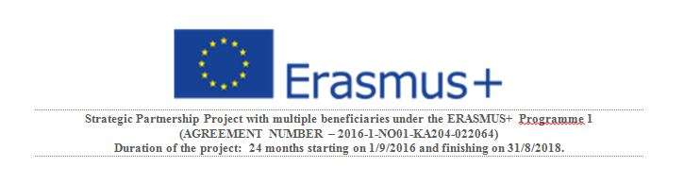

ICON EVALUTION TEST

Please fill in this form: it will help us to understand whether your expectations were met and how we can improve. Titolo predefinito
The organization of the meeting in the whole seemed:
  - Adequate
  - Effective
  - Functional
The informations received have been
  - Precise
  - Understandable
  - On time
1 bad - 4 very good
  - Opzione 1
The program was revealed on time to allow participants to organize the trip
 | 1 | 2 | 3 | 4
The calendar of the program has been respected
 | 1 | 2 | 3 | 4
The needs of the participants have been taken into account
 | 1 | 2 | 3 | 4
Has been possible to create a communication network between the participants
 | 1 | 2 | 3 | 4
Functionality and comfort of the rooms used
 | 1 | 2 | 3 | 4
Time management
 | 1 | 2 | 3 | 4
Adequacy of the location
 | 1 | 2 | 3 | 4
Easy access to the places of the training
 | 1 | 2 | 3 | 4
Adequacy of available equipment (video projector, overhead projector, etc.).
 | 1 | 2 | 3 | 4
The contents emerged
  - were already known
  - were not of your knowledge
  - were part of your knowledge, but you wanted deepen
The themes:
  - Have been sufficiently deepened
  - Have not been sufficiently deepened
  - They have been widely approfondidti
Has been created a climate of openness to dialogue and cooperation among the teachers ?
  - yes
  - no
  - enough
The methodology used seemed
  - appropriate
  - Inadequate
  - just appropriate
How would you rate your level of involvement (interest in the content, interventions during class, etc.)?
 | 1 | 2 | 3 | 4
How would you rate the amount of the distributed educational material?
 | 1 | 2 | 3 | 4
And its quality?
 | 1 | 2 | 3 | 4
How would you rate the technical tools used?
 | 1 | 2 | 3 | 4
How would you rate the video-lessons in terms of clearness and interest?
 | 1 | 2 | 3 | 4
Was the Camtasia software used easy to use and understand?
 | 1 | 2 | 3 | 4
In what percentage were the expectations you had at the beginning of the course met?
 | 1 | 2 | 3 | 4
Write here your suggestions or criticisms
.

